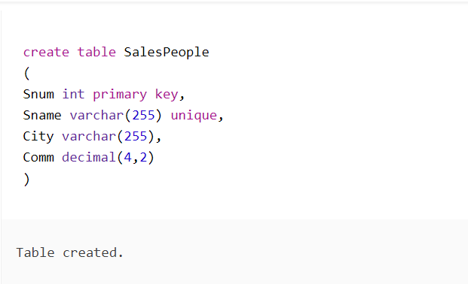

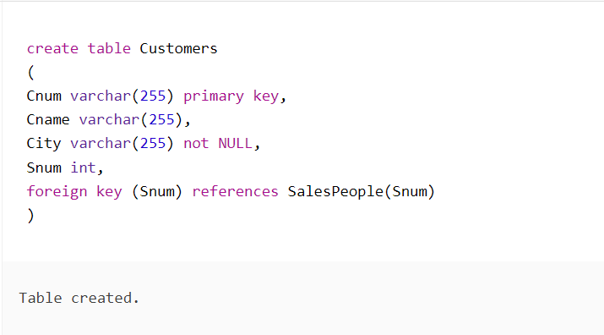

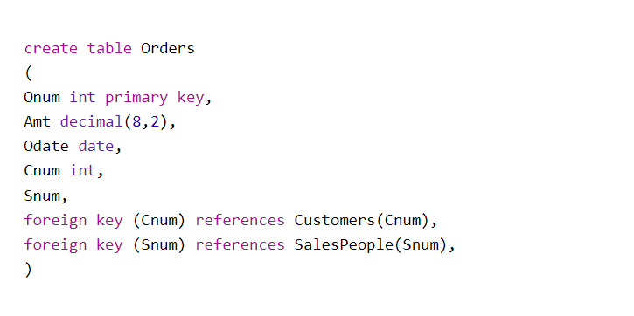

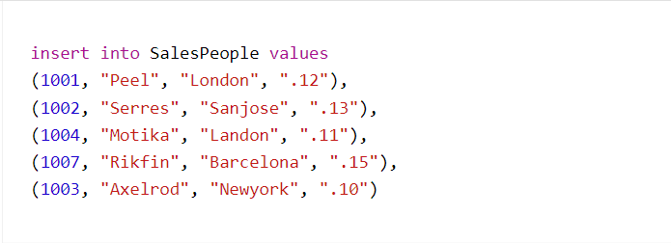

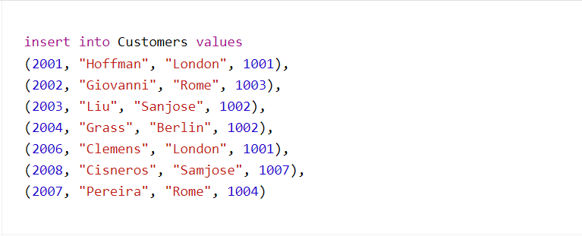

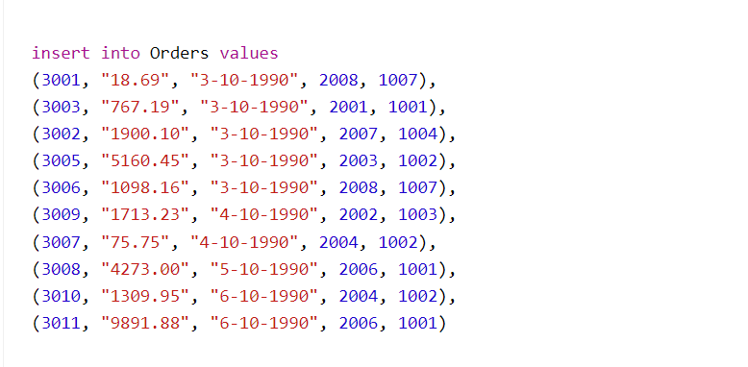

1) Count the number of Salesperson whose name begin with ‘a’/’A’

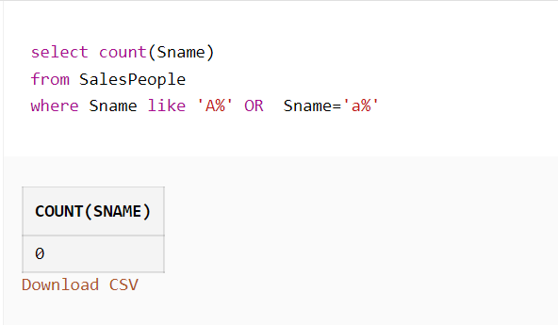

2) Display all the Salesperson whose all orders worth is more than Rs. 2000.

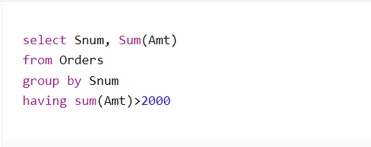

3) Count the number of Salesperson belonging to Newyork.

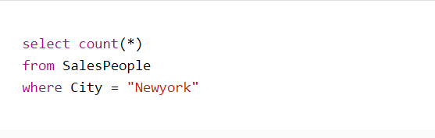

4) Display the number of Salespeople belonging to Landon and belonging to Paris.

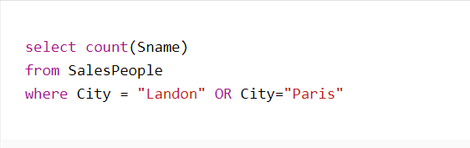

5) Display the number of orders taken by each Salesperson and their date of orders.

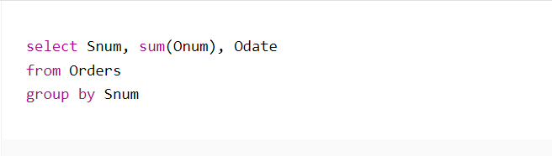

6) Write a query that counts the number of Salespeople registering orders for each day.

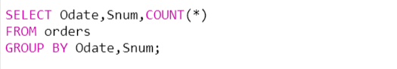

7) Write a query that selects the first customer in alphabetical order , whose name begins with ‘G’.

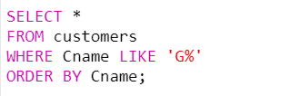

8) Find out the largest orders for Snum 1002 & 1007.

